**AUTOMATED ALERTS Pricing**

**1.Mediastack (https://mediastack.com):**

Covers 7500+ news websites for 50+ countries in 13 languages.

Plans: Please refer this website for the same (https://mediastack.com/pricing)

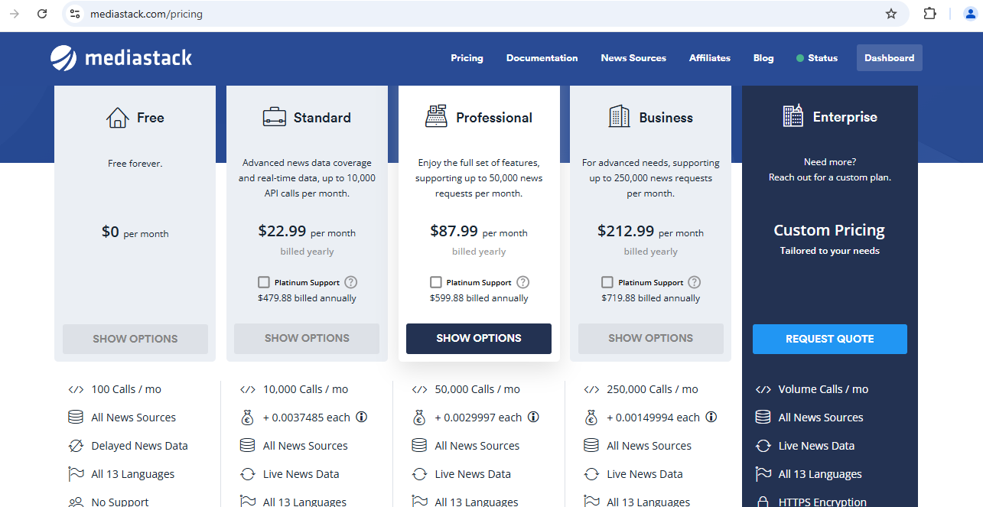

1. **Newsapi (**[**https://newsapi.org/**](https://newsapi.org/)**)**

Covers 150,000 news wesbites from 50+ countries in 13 different languages.

Plans: Please refer this website for the same (<https://newsapi.org/pricing>)

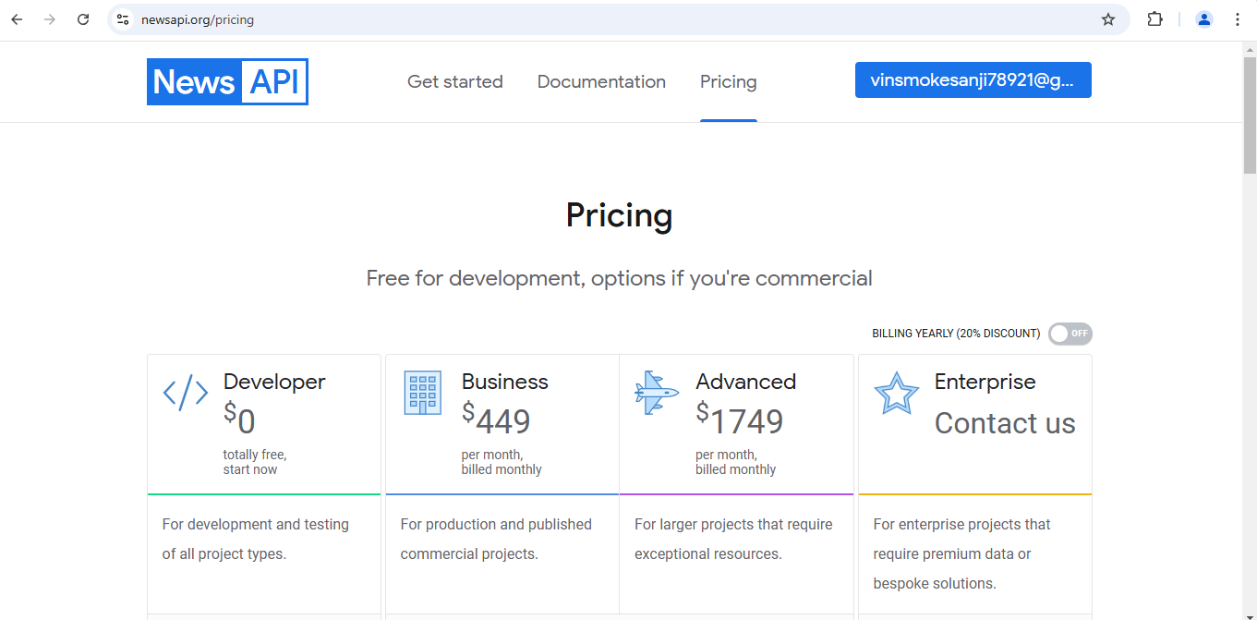

**3.Apify (https://apify.com/):**

For social media posts and descriptions.

Covers twitter, Instagram, linkedin.

Plans: Pay-as-u-go plan. (<https://apify.com/pricing>)

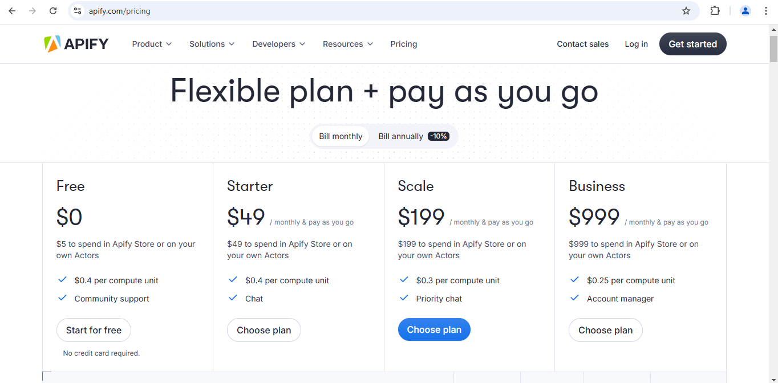

**4.WhatsApp API: (https://business.whatsapp.com/products/platform-pricing?country=India&currency=Indian%20Rupee%20(INR)&category=Marketing)**

|  |  |  |  |  |  |  |
| --- | --- | --- | --- | --- | --- | --- |
| Market | Currency | Marketing | Utility | Authentication | Authentication-  International | Service |
| India | Rs. | 0.7846 | 0.115 | 0.115 | 2.3 | 0 |
|  |  |  |  |  |  |  |

**5.Twilio: (https://www.twilio.com/en-us/whatsapp/pricing)**

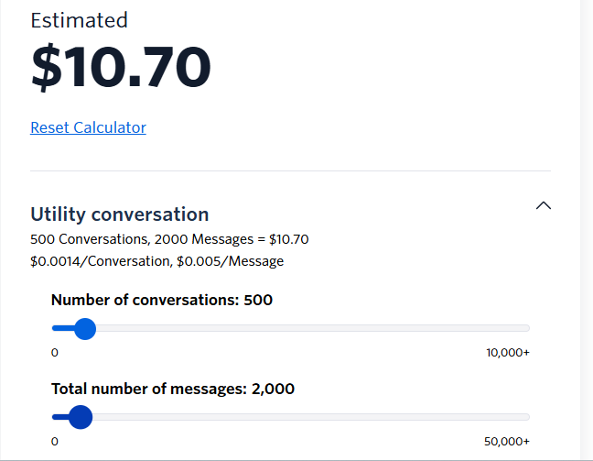

**AWS Lambda:**

Free:- 1 Million Request per Month, 400,000 GB-seconds of compute time per month

Source: (<https://aws.amazon.com/pm/lambda/?gclid=EAIaIQobChMIuu-X2I7eiwMVGMQ8Ah3wUjIZEAAYASAAEgJMt_D_BwE&trk=5cc83e4b-8a6e-4976-92ff-7a6198f2fe76&sc_channel=ps&ef_id=EAIaIQobChMIuu-X2I7eiwMVGMQ8Ah3wUjIZEAAYASAAEgJMt_D_BwE:G:s&s_kwcid=AL!4422!3!651612776786!p!!g!!lambda!19828229697!143940519581>)

Paid:

Compute charges: $0.0000166667 per GB-second (if computation passes above hit above 400,000 GB per Second)

Requests Charges: $0.20 per 1 Million requests after 1 Mil requests per month

Calculation:

Total Monthly Charges = 0.20 * (per 1 million requests) + 0. 0000166667 * (per GB-Seconds)

**AWS S3:**

S3 Standard:

Storage: For first 50TB/Month = $0.023 per GB

Data Retrivals: PUT, COPY, POST, LIST requests (per 1,000 requests) = $0.005

GET, SELECT, and all other requests (per 1,000 requests) = $0.0004

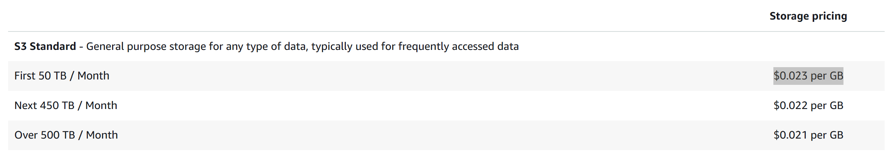

Source: <https://aws.amazon.com/s3/pricing/>

**AWS RDS POSTGRES:**

RDS Instance (db.m6g.large): $232.14

Storage (110 GB SSD): $12.65

Backup (less than 110 GB): Free

Outbound Data Transfer (10 GB beyond free limit): $0.90

Total Estimated Cost: $245.69 per month

**6.API COSTS**

**For Now considered only Groq and News api**

**Groq Api Charges:** [**https://groq.com/pricing/**](https://groq.com/pricing/)

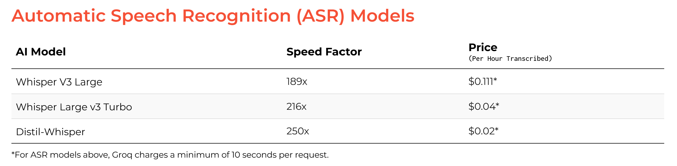

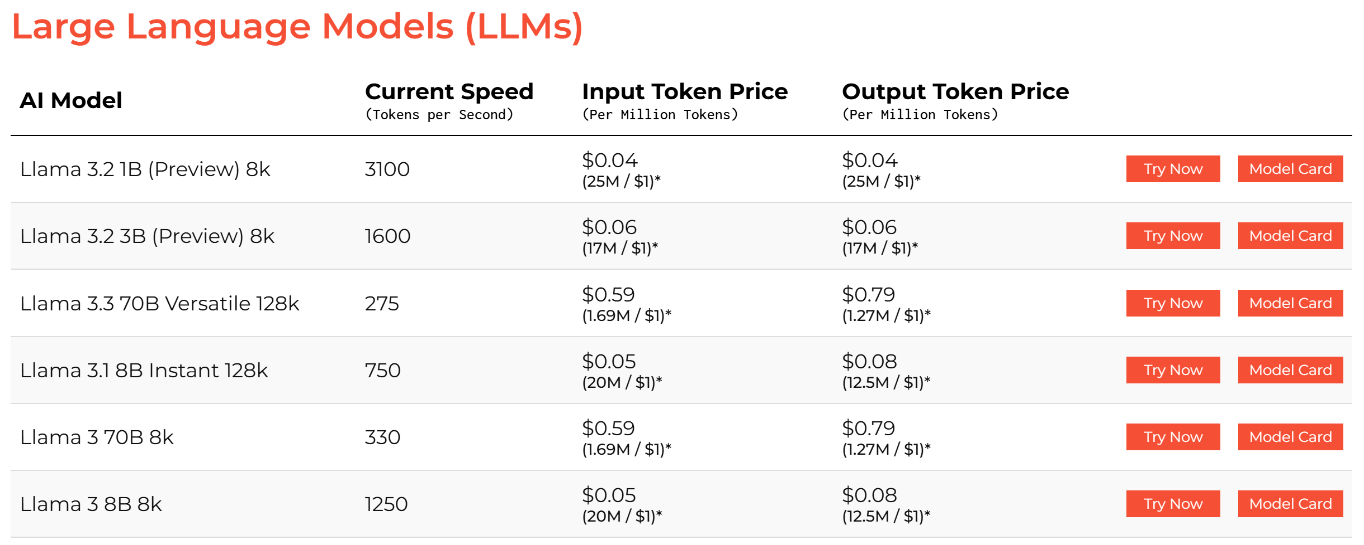

**POWER BI DASHBOARD :**

|  |  |  |  |
| --- | --- | --- | --- |
| **Resource** | **AWS (Est.)** | **Azure (Est.)** | **Optimization Tip** |
| **API Gateway (1M reqs)** | **$4–$7** | **$4–$8** | Use HTTP API instead of REST API |
| **Lambda / Functions (1M)** | **$5–$10** | **$6–$12** | Optimize execution time & memory |
| **S3 / Blob (100GB)** | **$2–$5** | **$3–$6** | Use Intelligent-Tiering / Glacier |
| **Athena / Synapse** | **$5–$10** | **$7–$15** | Use Parquet + Partitioning |
| **Power BI Pro** | **$10/user** | **$10/user** | No optimization (fixed cost) |
| **Logging & Monitoring** | **$2–$5** | **$3–$7** | Retention policies & log filters |
| **Total Monthly Cost** | **$28–$47+** | **$33–$58+** | AWS is slightly cheaper |

All the pricings are estimated .